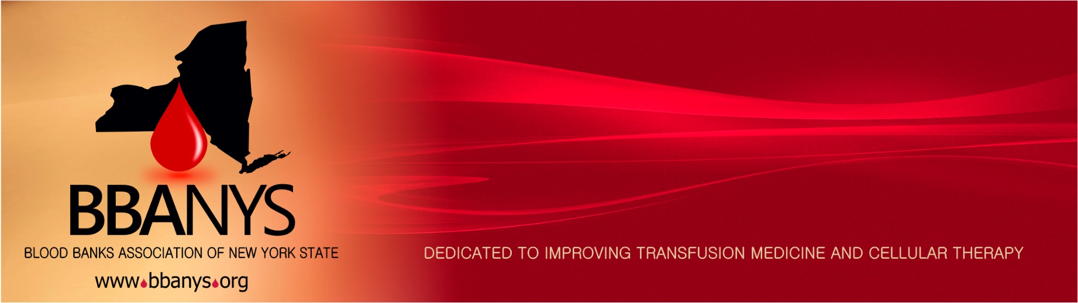
The Barb Gonnella Fostering Future Leaders Award is presented in memory of Barb Gonnella’s contribution to BBANYS. Barb was a dedicated leader who was active in many aspects of the BBANYS including the coordination of the newsletter and the annual meetings. This Award includes complimentary admission to the BBANYS Annual Meeting.
2020 BBANYS Annual Meeting The Barb Gonnella Fostering Future Leaders Award
Nomination Form

Nominees must meet the following qualifications:
- BBANYS member in good standing (including Student members)
- Blood bank/transfusion professional for less than 10 years
- Demonstrated leadership and/or innovation in an aspect of improving quality in transfusion medicine.
Name of Nominee: __________________________________________________________________________
Nominee Email:_____________________________________________________________________________
Nominee Phone:______________________ Place of employment____________________________________
Nominee Address:___________________________________________________________________________
Years in Blood Bank/Transfusion field (must be less than 10 years to qualify):_________________________________
Please give a short example or explanation of how the Nominee has shown leadership/innovation in the field:
__________________________________________________________________________________________
__________________________________________________________________________________________
__________________________________________________________________________________________
__________________________________________________________________________________________
__________________________________________________________________________________________
__________________________________________________________________________________________
__________________________________________________________________________________________

Nominations may be submitted by any member in good standing; self-nominations are acceptable. Completed forms must be submitted by April 16, 2021, to the BBANYS Central Office (bbanys@bbanys.org – Fax 651-317-8048). The winner will be notified.

Form Submitted By: _________________________________________________________________________
Email:___________________________________ Phone:___________________________________________
Address: __________________________________________________________________________________
2345 Rice Street, Suite 220, St. Paul, MN 55113 · Phone: (866) 397-8883 · Fax: (651) 317-8048 · Email: bbanys@bbanys.org

